2023 Lancaster University

CSS 201 Lab Week 1

**Instructions:**

This week you will gain hands-on experience with reading/writing Entity-Relationship diagrams (ER diagrams for short).

You are free to discuss your answers with your classmates.

**TASK 1: Getting familiar with draw.io.(The expected time of work is 20 mins)**

**Follow the steps:**

1. Write Draw.io in the search bar and then press enter.

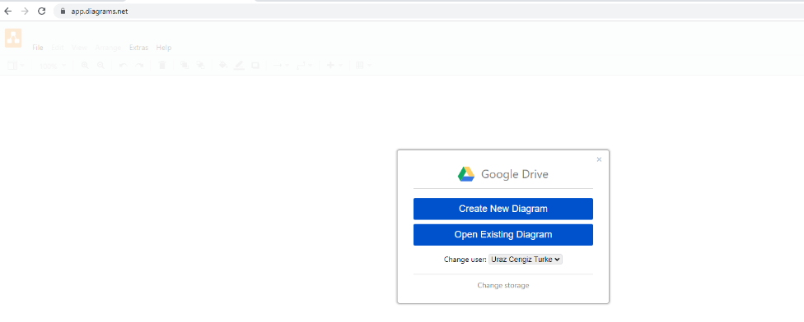

1. Click on the Entity Relationship Diagram button and then press Create.

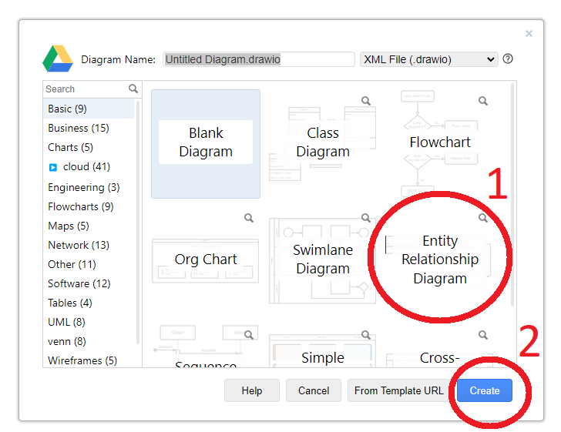

1. Use the root folder or create a new folder.
2. You will see a page like the following.

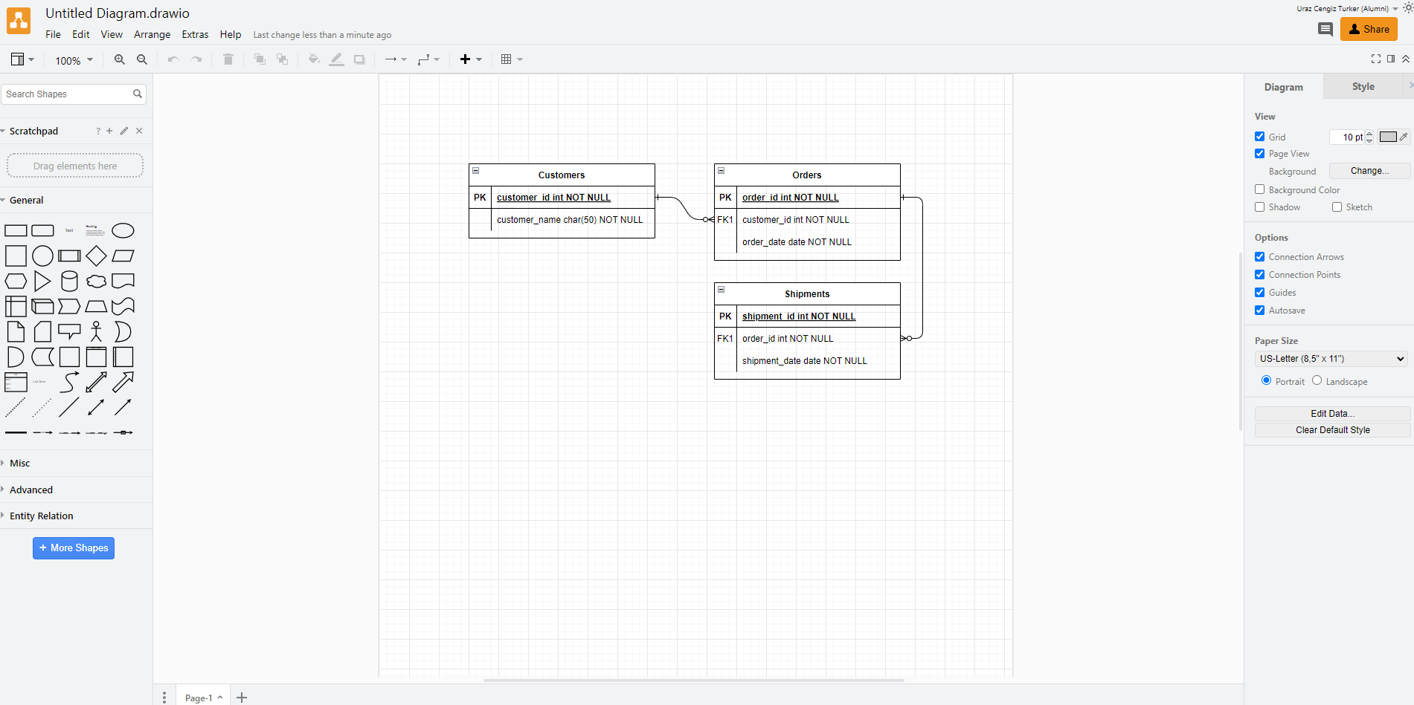

1. Press CTRL + A and then press Delete. This will clear the screen for you (or create a new page.).
2. Click the Entity Relation tab to see the built-in images.

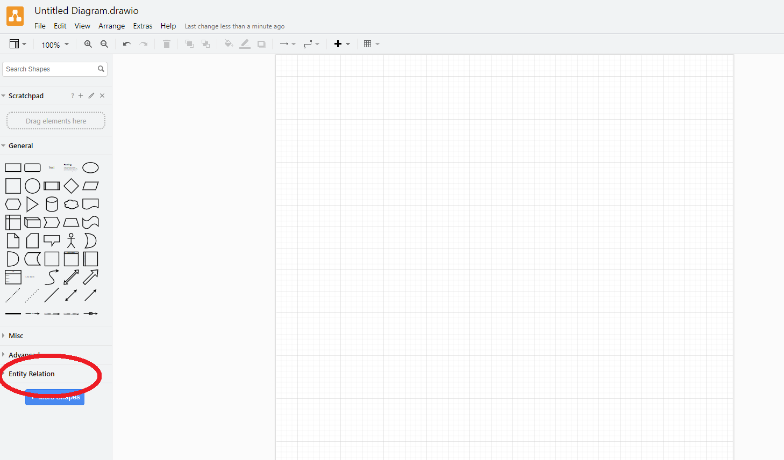

1. Familiarise yourself by drawing the below ER diagrams

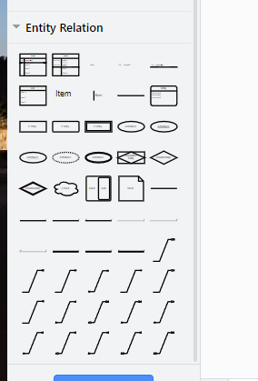

**Notes:**

The attribute that uniquely identifies an entity within this entity set is called a ‘**key attribute’**

Some attributes are computed**: Derived attributes.**

**Multi values : Multiple values.**

**TASK 2 EXERCICES (The expected time of work is 90-100 mins)**

**Text to ER diagram**

For the following expressions:

1. Identify the Entity sets (rectangular shape) with their attributes and their properties (key attribute (underlined text), Derived Attribute (dashed ellipse), Multi-valued Attribute (double-lined ellipse)).
2. Write their explanations.
3. Draw the ER diagrams (you can use draw.io to draw):

Expression 1: “A customer has a name, SSN, Account No, and Balance.”

1. Entity: Customer, Attributes: Name, SSN, Account No, Balance, Key attribute: SSN, Account no

Expression 2: “A fish has weight (in KG.), and price per gram value, its type”

a)Entity: Fish, Attributes: Price, weight, Derived Attributes: Price per gram, Multi : Type

Expression 3: “There are football teams and players. Each football player has a name, surname, age, and role. You may assume that football players have distinct name-surname combinations. Teams have names, coaches, and sponsors. Names of the teams are unique.“

Expression 4: “Car has colours”.

1. Entity: Car, Attributes: Type model Make, derived atrtbiute: Color

Expression 5: “A computer game has Name, Year, System Reqs, Pictures, Developers, Programming Language, Owner ID”.

**ER Diagram to text**

For the following ER diagrams, write their English explanations.

